DS-210 Final Project Part 1

Batsheva Levin

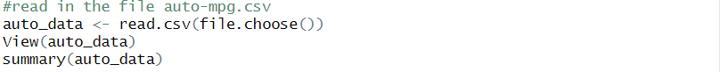









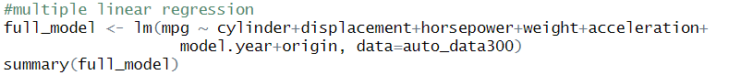

(this is only a sample of the predicted and actual values)





